

Subject: Publication of paper at International Journal of Emerging Technologies and Innovative Research .
Ref No : JETIR / Vol 13 / Issue 1 / 060
Confirmation Letter
To,
Riddhisha Srivastava
Published in : Volume 13 | Issue 1 | 2026-01-08

Dear Author,

With Greetings we are informing you that your paper has been successfully published in the International Journal of Emerging Technologies and Innovative Research (ISSN: 2349-5162). Following are the details regarding the published paper.

About JETIR : An International Scholarly Open Access Journal, Peer-Reviewed, Refereed Journal Impact Factor Calculate by Google Scholar and Semantic Scholar | AI-Powered Research Tool, Multidisciplinary, Monthly, Multilanguage Journal Indexing in All Major Database & Metadata, Citation Generator, Impact Factor: 7.95, ISSN: 2349-5162
UGC Approval : UGC and ISSN Approved - UGC Approved Journal No: 63975 | Link: https://www.ugc.ac.in/journallist/subjectwisejurnallist.aspx?tid=MjM0OTUxNjI
=&&did=U2VhcmNoIGJ5IElTU04= Registration ID : JETIR 574250
Paper ID : JETIR2601060
Title of Paper : Tone Tracer: Decoding The Hidden Meaning Impact Factor : 7.95 (Calculate by Google Scholar)
DOI : https://doi.org/10.56975/jetir.v13i1.574250 Published in : Volume 13 | Issue 1 | 2026-01-08 Publication Date: 2026-01-08
Page No : a490-a494
Published URL : http://www.jetir.org/view?paper=JETIR2601060
Authors : Riddhisha Srivastava, Anurag Shrivastava, Sachin Tripathi, Anshika Mishra, Ishaan Tripathi

Thank you very much for publishing your article in JETIR. We would appreciate if you continue your support and keep sharing your knowledge by writing for our journal JETIR.

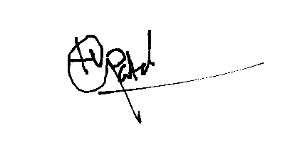
Editor In Chief  International Journal of Emerging Technologies and Innovative Research
(ISSN: 2349-5162)

www.jetir.org | editor@jetir.org | Impact Factor: 7.95 (Calculate by Google Scholar)

